Gobang Game Design Based On C#

Yan Xu

Software Requirements Specification

Document

Version: (01) Date: (02/28/2021)

1. Abstract

Gobang is a two-player abstract strategy game generally played with Go pieces on a Go board. The Gobang game with computer implement this traditional game online with computer AI based on C# and implement data structure, algorithms and game design thinking to create a online game.

2. The Overall Description

Gobang is a simple and popular game, also called Gomoku, or Five in a Row (FIR). It is a logic board game played by two persons. It is played with black and white stones on a 15x15 intersection Go board made of wood.
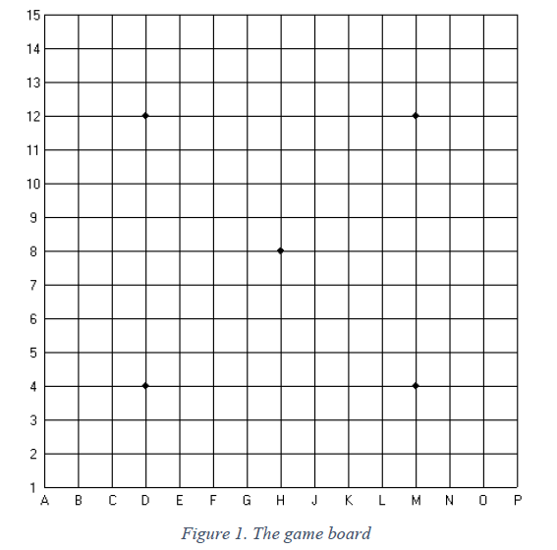

2.1 Product Perspective

In the beginning of the game the board is empty. The player who controls the black pieces always starts the game. Moves must be placed on the intersections of the board, not on the squares closed by the lines. Black stone plays first, then white stone takes its turn, and this process continues until the end of the game. The players alternate in placing a stone of their color on an empty intersection.

The stones put on the table remain untouched till the end of the game. Getting down, removal or touching of stones are forbidden. It is naturally allowed to adjust a position of a piece when it is preceded by a sign. The winner is the first player to get an unbroken row of five stones either horizontally, vertically, or diagonally. Winning the game requires a row of exactly five stones; a row of six or more stones called overline -does not count.
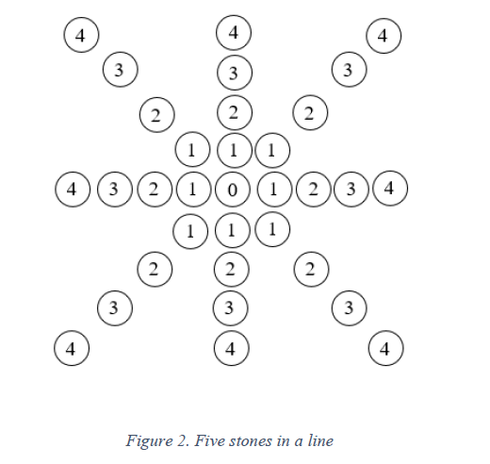
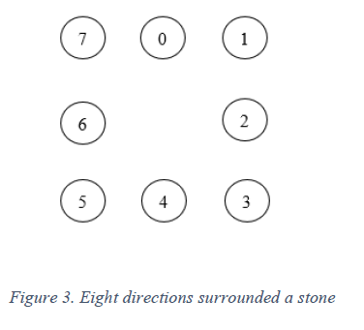

The development environment as below:

1. Operating System: Windows 10

2. Developing Tool: Windows command-line tools.

3. Programming Language: Microsoft Visual Studio,C#, HTML5/CSS3

2.2 Product Functions

- Display a 15 * 15 gaming board
- Put stones on the board by clicking mouse, display stones at the position where the mouse clicked, and the stones located on the cross line.
- Automatically judge if the game is over, won by black or white, and pop up dialog showing the winning player.
- Steps function, recording the totally steps have done.
- Set entry level and advanced level. 6. Set AI first or Human First function.

2.3 User Characteristics

- User Stories
New players want to know what Gobang Game is and how to play.
General players enjoy the game and get better rank.
Advanced players, compute speed and make record/ or find the game bug.
- Use-Case(s)
Scenario (1):
Player need the game with the button in Chinese.
Scenario (2):
Player never play Gobang game before, he needs the instructions for this game.
Scenario (3):
Player is hesitated to move the piece; he need a reminder to remind himself how long he takes for one move.
Scenario (4):
Player wants to look at the previous rank, he needs log-in function to retrieve his game information.
Scenario (5):
Player wants to share this game and he want to send link automatically when he clicks the share button to Facebook or Instagram or other social media with game logo.
- Use-Case Diagram (UML)
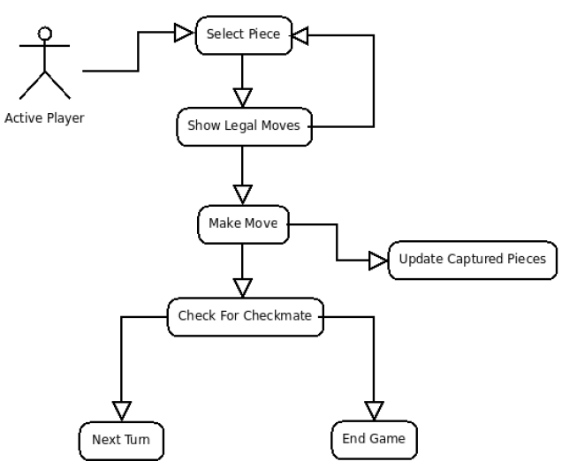
- Requirements (List) (10-20)
Level 1 Play Gobang game with computer
Level 2 Record the result and get rank.
Level 3 Game share function via social media.
Specific requirements as below:
0100 Users shall be able to connect via IP address. Level 1
0110 Users shall be able to start a game once two users are connected. Level 1
0120 Users shall be given the choice of who plays black and white. Level 1
0130 Each user is to have their pieces start at the bottom of the board on their display. Level 1
0140 The player playing white is first to move. Level 1
0150 A player may forfeit at any time during gameplay. Level 1
0160 A player must be given a confirm dialog before forfeiting. Level 2
0170 Forfeiting shall end the game immediately. Level 1
0180 The active player shall select a piece by clicking it. Level 1
0190 When a piece is selected, all legal moves for that piece are highlighted. Level 1
0200 When a piece is selected, the active player may select another piece by clicking it. Level 1
0210 A selected piece must always belong to the active player. Level 1
0220 The active player shall move the selected piece by clicking on any legal square. Level 1
0230 The active player shall capture a piece by moving onto a legal square containing an opposing piece. Level 1
0240 Captured pieces shall be displayed in a captured pieces box. Level 2
0250 The inactive player may request to undo the prior move. Level 2
0260 There shall be no more than one undo request per turn. Level 2
0270 An undo request shall be ratified by the active player. Level 1
0280 When an undo request is accepted the game is reverted to the state of the board prior to the request. Level 1
0290 A player shall be able to save a log of the moves at any time. Level 2

